SIMATS ENGINEERING (SAVEETHA SCHOOL OF ENGINEERING)
Department of Computer Science and Engineering

CO1 ASSESSMENT TOOL 1 – CASE STUDY ANALYSIS

Course Code | Course Title | Assessment | CO
CSA10 / CSA1004 | Software Engineering | Case Study Analysis | CO1

Student Name | Register Number | Date | Problem No.
K. Chandana | 192525363 | 10/10/2026 | 27

27. INTELLIGENT TOURISM RECOMMENDATION AND TRIP PLANNING
SYSTEM

1. Understand the Problem Statement
Tourists often need to search several websites and applications to compare destinations, hotels, transport, attractions, restaurants and activities. This process takes time, and general recommendations may not suit a traveller’s interests, budget, location or available days. The proposed Intelligent Tourism Recommendation and Trip Planning System brings these tasks together and prepares a personalized, practical itinerary.

Objectives
- Manage tourist profiles and travel history.
- Collect preferences such as destination type, interests, budget, travel dates and trip duration.
- Recommend suitable destinations and attractions.
- Generate a day-wise itinerary and support trip scheduling.
- Display attraction details and estimate transport, accommodation, food and activity costs.
- Collect ratings and feedback to improve future recommendations.

Scope
The system covers profile management, preference collection, destination discovery, itinerary generation, attraction information, approximate cost estimation, scheduling and feedback. A prototype can use sample destination data and estimated prices. Live hotel bookings, ticket purchases, real-time traffic and payment processing are outside the initial scope unless external services are integrated.

2. Key Stakeholders and Challenges

Stakeholder | Role / responsibility | Main challenge
Tourists / users | Enter interests, dates, budget and constraints; review and rate plans. | Too many choices, limited time and unexpected costs.
Travel administrators | Maintain destination, attraction, safety and seasonal information. | Keeping listings accurate and up to date.
Hotels, restaurants and activity providers | Supply service details, prices, location and availability. | Showing reliable prices and current availability.
Transport providers / map services | Provide routes, distances, travel options and estimated times. | Traffic, route changes and incomplete data.
Development team / project manager | Design, implement, test and maintain the application. | Integrating modules and meeting deadlines.
System administrator | Manage access, backups, security and reported issues. | Protecting personal data and preventing misuse.

Major Challenges
- Preference diversity: families, solo travellers, adventure seekers and cultural tourists need different plans.
- Budget accuracy: prices vary by season, availability, taxes and provider.
- Scheduling: travel time, opening hours, meal breaks and attraction duration must fit into each day.
- Data quality: inaccurate location, opening-hour or safety information can reduce trust.
- Privacy and security: profiles, travel dates and contact details must be protected.
- Usability: the plan should be easy to read and modify on a phone or computer.

3. Analyze the Current Approach
At present, a tourist may use search engines, blogs, maps, hotel platforms, restaurant reviews and spreadsheets separately. The traveller manually compares options, calculates expenses and arranges places into a timetable. Recommendations from blogs or popular lists may not consider the person’s complete preferences.

Strengths
- Many websites provide a large amount of destination information, photos, reviews and price comparisons.
- Users can compare alternatives and retain control over their decisions.

Limitations and gaps
- Information is scattered across multiple platforms and repeated searches consume time.
- Generic lists do not consistently balance personal interests, budget and trip duration.
- Manual scheduling may create long travel distances, overlapping activities or missed opening hours.
- Cost estimates may omit local transport, meals, entry fees or contingency expenses.
Therefore, an integrated recommendation and itinerary tool is needed to organize information, explain estimated costs and allow users to revise the plan.

4. Proposed Software-Based Solution
The proposed system accepts a tourist profile and trip preferences, filters destination options, scores matching places, and creates a day-wise itinerary. Users can edit the plan, inspect attraction information, review an estimated budget and submit feedback.

Major Functional Modules
Module | Function
1. Tourist Profile | Stores name or user ID, preferred travel style, interests and optional accessibility needs.
2. Preference Collection | Captures origin, dates, duration, number of travellers, budget and interests.
3. Destination Recommendation | Filters by location and budget, then ranks places by interest match, ratings and trip suitability.
4. Itinerary Generator | Groups attractions by day and nearby location, considering opening hours and approximate visit duration.
5. Attraction Information | Shows description, address, category, timings, entry fee and visitor notes where available.
6. Cost Estimator | Adds estimated accommodation, transport, meals, entry fees and activities; displays a contingency allowance.
7. Trip Scheduler | Shows a day-wise schedule and allows users to change order, duration or selected places.
8. Feedback | Collects ratings and comments to help administrators improve information and recommendation rules.

Illustrative Workflow
Step | System action | Output
1 | User enters dates, budget, location and interests. | Travel preference profile
2 | System filters and scores candidate places. | Ranked destination suggestions
3 | User selects preferred places. | Selected attractions list
4 | System groups nearby places into days and estimates costs. | Draft itinerary and budget
5 | User reviews, edits and saves the plan. | Personalized trip plan
6 | After the trip, user submits ratings. | Feedback for improvement

Functional Requirements
- The system shall create and update tourist profiles.
- It shall validate required preferences such as dates, duration and budget.
- It shall recommend destinations and attractions based on user preferences.
- It shall generate and allow editing of a day-wise itinerary.
- It shall calculate and display itemized estimated costs.
- It shall save the itinerary and accept ratings or comments.

4. Proposed Solution (continued)
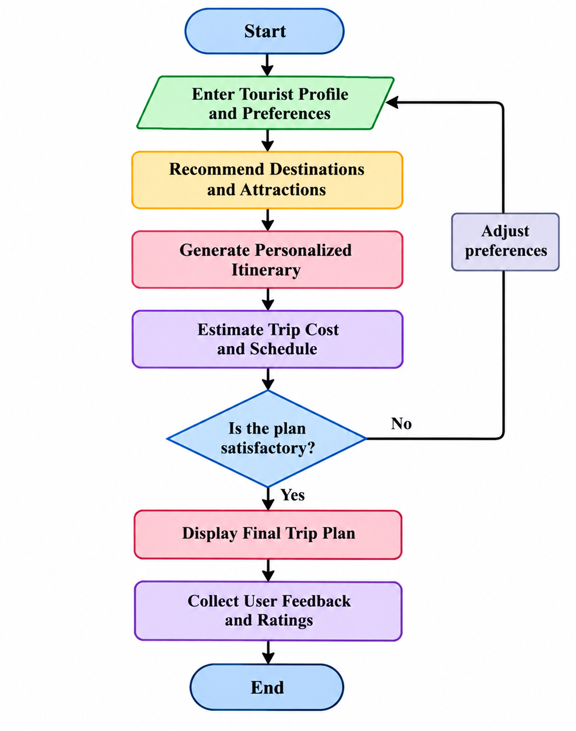

Non-Functional Requirements

Requirement | Application to the system
Usability | Clear forms, readable itinerary, simple navigation and understandable cost breakdown.
Performance | Return recommendations and generate a sample itinerary within a reasonable response time.
Reliability | Validate inputs, handle missing data and avoid duplicate or overlapping schedule entries.
Security & privacy | Use authenticated access where applicable, restrict profile access and avoid exposing personal travel details.
Maintainability | Keep recommendation, scheduling, cost and profile functions in separate modules.
Scalability | Allow more destinations, users and data sources to be added without redesigning the whole application.
Accuracy & transparency | Label prices and travel times as estimates and show the assumptions or last-updated date when available.

Software Engineering Principles
Modularity separates profile management, recommendations, itinerary generation, cost calculation and feedback. This makes individual modules easier to test and update. Scalability can be supported through structured destination data and service interfaces. Maintainability improves when business rules are documented and duplicated logic is avoided. Reliability is supported by input validation, error handling, schedule checks and backup procedures. Usability is addressed through a consistent interface and editable plans. Security is supported by access control, data minimization and secure handling of stored information.

Illustrative Recommendation Logic
A simple prototype can score each destination using weighted criteria: interest match (40%), budget suitability (25%), user rating (20%) and travel-time suitability (15%). The weights are example values and should be tested with user feedback. Places outside the budget or unavailable during the selected dates can be filtered out before ranking. The system should explain that recommendations are suggestions, not guarantees.

Cost Estimation
Estimated trip cost = accommodation + transport + meals + attraction entry fees + activities + contingency. For example, if the sample costs are ₹3,000 for accommodation, ₹1,200 for transport, ₹1,000 for meals and ₹800 for entry/activity fees, the subtotal is ₹6,000. A 10% contingency adds ₹600, giving an estimated total of ₹6,600. These are illustrative values only, not live prices.

Prototype Data
A destination record may contain destination ID, name, location, categories, interest tags, average visit duration, opening hours, estimated entry fee, rating and last-updated date. Keeping these fields consistent helps the recommendation and scheduling modules work together.
5. Chosen Methodology / Framework: Agile Scrum
Agile Scrum is suitable because the system has several modules and user preferences may change after seeing a working prototype. The team can develop a small usable version first, gather feedback, and improve recommendations and scheduling in short iterations. Jira can be used to maintain the product backlog, plan a sprint, assign work and track progress.

Suggested One-Week Sprint
Day 1: create the Jira Scrum project, product backlog and sprint goal. Day 2: build the profile/preferences form and sample dataset. Day 3: implement recommendation rules. Day 4: create itinerary and cost-estimation logic. Day 5: test normal and invalid inputs. Day 6: demonstrate the prototype and collect feedback. Day 7: fix defects, review completed work and record retrospective improvements.

Expected Outcomes
- More personalized travel suggestions and improved destination discovery.
- Reduced time spent switching between websites and manually planning a trip.
- Clearer budget estimates and better awareness of major trip expenses.
- A structured schedule that can be reviewed and adjusted.
- Feedback that supports continuous improvement and tourist satisfaction.

Limitations, Risks and Future Enhancements
Recommendations depend on the quality and freshness of destination data. Estimated prices may differ from actual prices, and traffic or availability can change. A prototype using sample data cannot guarantee bookings or real-time schedules. Other risks include privacy concerns, biased rankings and integration failures. Future versions could integrate maps and live route data, weather forecasts, verified accommodation availability, multilingual support, accessibility filters, offline itinerary access and explainable AI recommendations.

Screenshot 1: Jira project and product backlog showing the tourism tasks.

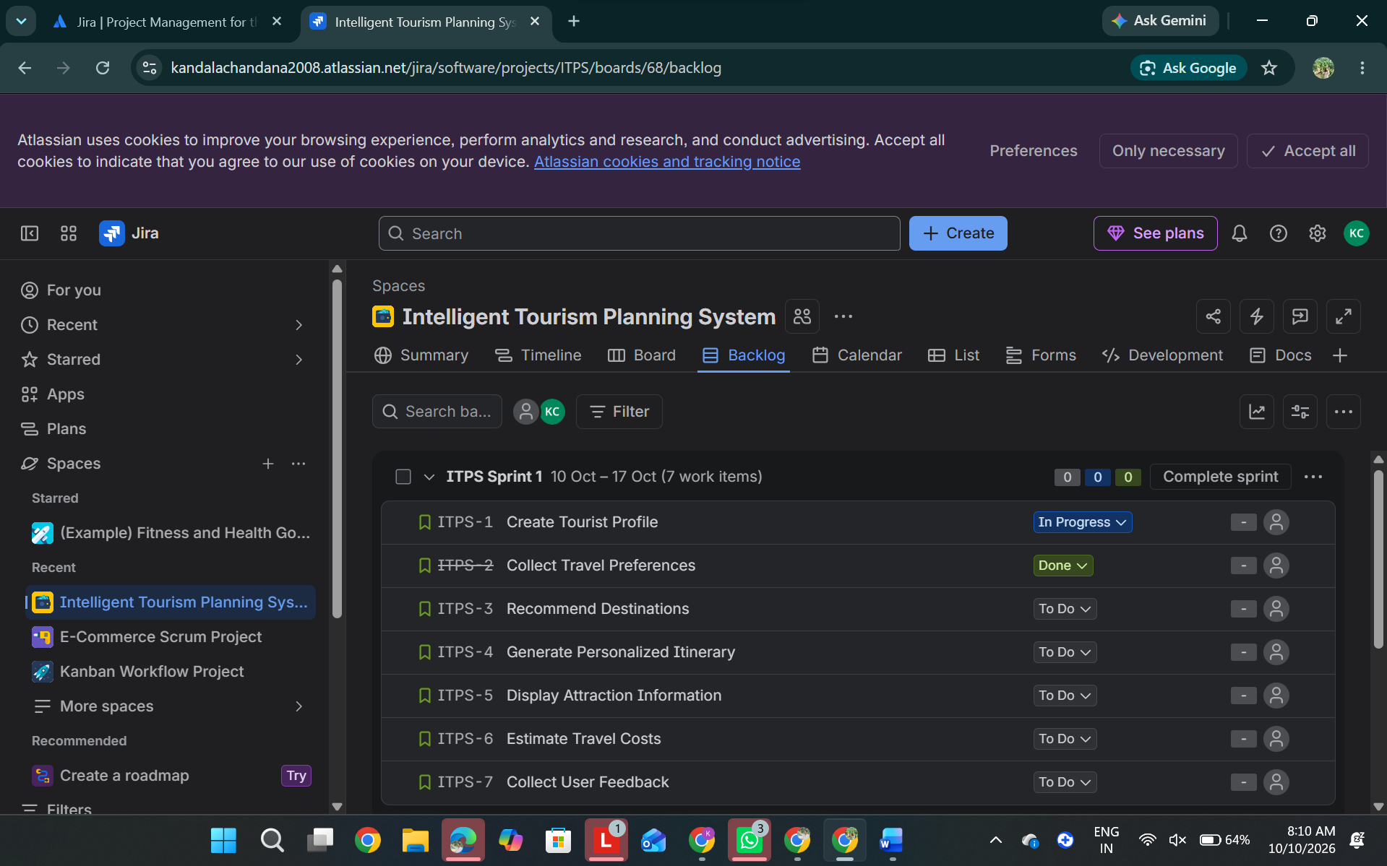

Screenshot 2: Sprint board showing To Do / In Progress / Done and task movement.

